Data Exploration
Submitted by
Navaneeth Krishna R

Table of Content
- Introduction
- Dataset Description
- Motivation for Studying the Dataset
- Hypothesis Tests
- Assumptions
- Research questions
- Conclusion
- Tracking Log

Introduction

Welcome to my research analysis, where we'll explore the numbers and facts about YouTube. Our dataset holds the secrets of the most popular YouTube channels. It's like opening the door to the glamorous world of YouTube stardom. This collection is all about the big players on YouTube, the real giants. So, get ready to dig into the data and find valuable insights from these YouTube superstars. Let's discover the magic behind the most subscribed channels on the platform.

Data Description
The data set is downloaded from Kaggle. The data gives us a clear insight into the type of content which is shared in the recent times. The quantitative variables explained here are the subscribers, views, uploads, highest earnings, and population. The categorical variable includes name of channels, category of channels and the country of origin. The data consist of 12454 records with 10 columns.
Reasons to Explore the Dataset:
- Regional Impact: Uncover influential YouTube content creators from various countries and assess their global influence.
- Content Trends: Investigate the most favored content categories and upload frequencies that connect with viewers.
- Earnings Examination: Examine the relationship between channel performance and estimated earnings.

Chi Square Test
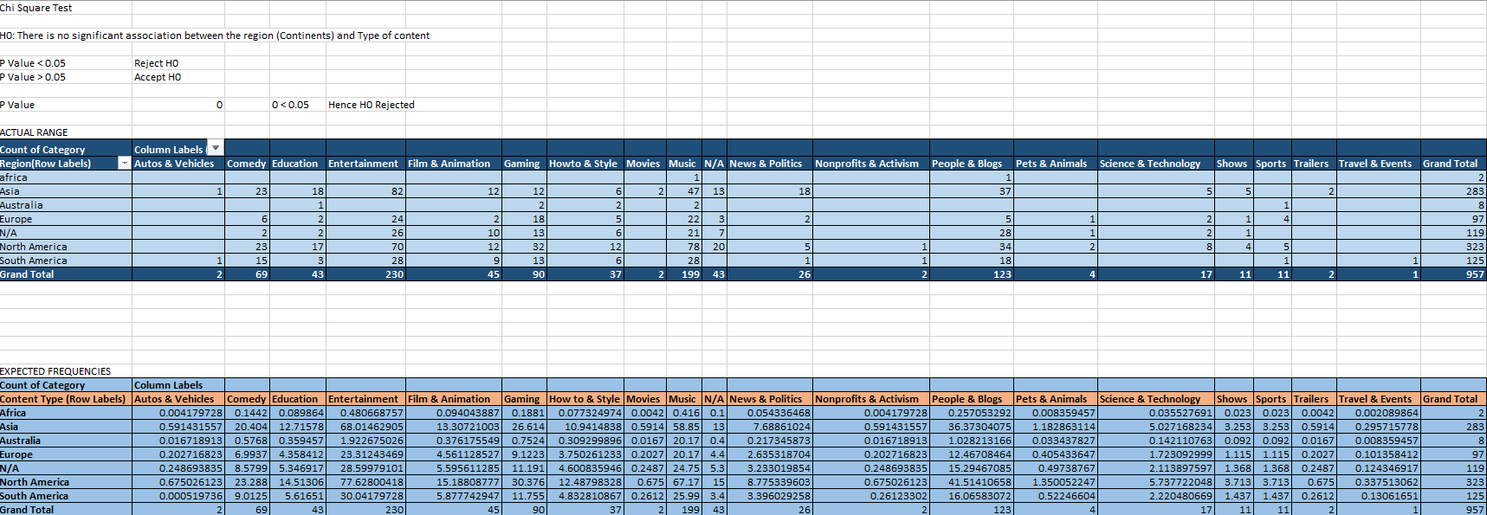

The null hypothesis (H0) stated that there is no significant association between the region and the type of content. The significance level (P-value) was set at 0.05.
Summary
- The observed frequencies indicate the actual counts of each combination of region and content type.
- The expected frequencies represent the values that would be expected if there were no association between the region and content type.
The chi-square test compares the observed and expected frequencies to determine if the differences between them are statistically significant. If the P-value is less than 0.05, it is common to reject the null hypothesis.
In this case:
- The P-value is reported as 0 (P Value = 0).
- Since the P-value is less than 0.05 (P Value < 0.05), the null hypothesis is rejected.
Conclusion
Therefore, there is evidence to suggest a significant association between the region (Continents) and the type of content. The observed distribution of content types across regions is different from what would be expected if there were no association between these two variables. The rejection of the null hypothesis implies that there is a statistically significant relationship between the region and the type of content on the platform.

Odds Ratio and Relative Risk Test
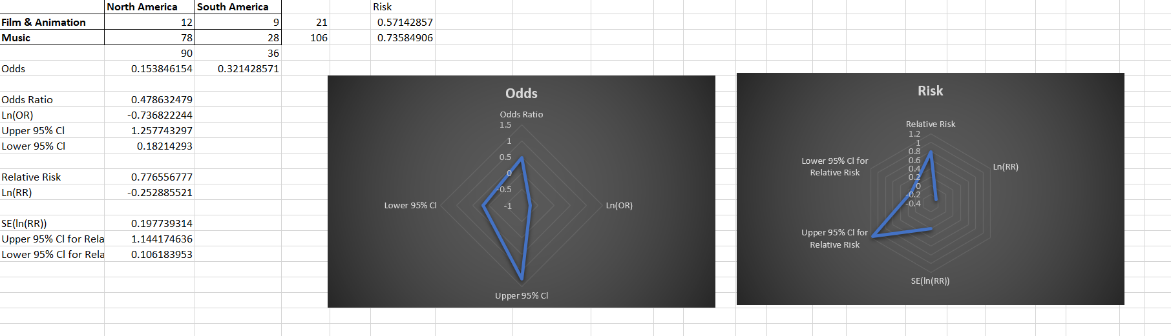

Comparing the odds and relative risk between North America and South America for the categories "Film & Animation" and "Music."
Summary
Odds:
For "Film & Animation," and “Music” the event, Youtubers working in North America are 0.153846154, and in South America, the odds are 0.321428571.
Odds Ratio:
The odds ratio is calculated as 0.478632479 for the combined data of "Film & Animation" and "Music."
Logarithm of Odds Ratio (Ln(OR)):
Ln(OR) is calculated as -0.736822244.
Confidence Intervals for Odds Ratio:
The upper 95% confidence limit for the odds ratio is 1.257743297.
The lower 95% confidence limit for the odds ratio is 0.18214293.

Relative Risk:
The relative risk for the combined data is 0.776556777.
Ln (RR) is calculated as -0.252885521.
Standard Error of Ln(RR):
SE (ln(RR)) is 0.197739314.

Confidence Intervals for Relative Risk:
The upper 95% confidence limit for the relative risk is 1.144174636.
The lower 95% confidence limit for the relative risk is 0.106183953.
The odds ratio is less than 1, indicating that the odds of the event occurring are lower in North America compared to South America. The confidence intervals provide a range of plausible values for these estimates. The relative risk is also less than 1, suggesting a lower risk in North America compared to South America.
T Test
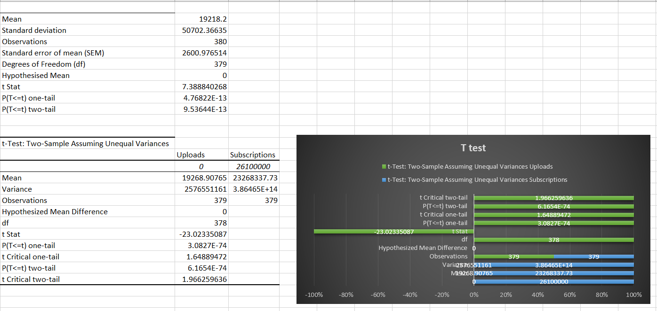

Summary of One Sample Test
- Mean:
  - The mean is the average value of the sample data. In this case, the mean is 19218.2.
- Standard Deviation:
  - The standard deviation measures the amount of variation or dispersion in a set of values. Here, it is 50702.36635.
- Observations:
  - The number of observations in the sample is 380.
- Standard Error of the Mean (SEM):
  - The standard error of the mean is an estimate of how much the sample mean is expected to vary from the true population mean. It is calculated as 2600.976514.
- Degrees of Freedom (df):
  - The degrees of freedom represent the number of independent values or quantities which can be assigned to a statistical distribution. For a one-sample t-test, df is equal to the number of observations minus 1. Here, df is 379.
- Hypothesized Mean:
  - The hypothesized mean is the value assumed to be true in the null hypothesis. In this case, it is 0.
- t Stat:
  - The t-statistic is a measure of how many standard errors the sample mean is away from the hypothesized population mean. Here, it is 7.388840268.
- P(T<=t) one-tail:
  - This is the p-value associated with the one-tailed test. It represents the probability of observing a t-statistic as extreme as the one calculated, assuming the null hypothesis is true. In this case, it is 4.76822E-13.
- P(T<=t) two-tail:
  - This is the p-value associated with the two-tailed test. It is generally used when you are interested in whether the sample mean is significantly different from the hypothesized mean in either direction. In this case, it is 9.53644E-13.
Explanation:
- The t-statistic of 7.388840268 is quite large, indicating that the sample mean is significantly different from the hypothesized mean.
- The very small p-values (4.76822E-13 and 9.53644E-13) suggest strong evidence against the null hypothesis.
- In hypothesis testing, you compare the p-value to a significance level (commonly 0.05). If the p-value is less than or equal to the significance level, you reject the null hypothesis. In this case, since the p-value is extremely small, you would typically reject the null hypothesis in favor of the alternative hypothesis that the true population mean is different from 0
t-Test: Two-Sample Assuming Unequal Variances

Summary
Data and Sample Characteristics:
- Uploads: Mean = 19268.90765, Variance = 2576551161, Observations = 379
- Subscriptions: Mean = 23268337.73, Variance = 3.86465E+14, Observations = 379
- Hypothesized Mean Difference:
The hypothesized mean difference is the difference between the means assumed in the null hypothesis. In this case, it is 0.
- Degrees of Freedom (df):
The degrees of freedom represent the number of independent values or quantities that can be assigned to a statistical distribution. For a two-sample t-test with unequal variances, the degrees of freedom are calculated using a more complex formula, but it's listed as 378 here.
- t Stat:
The t-statistic is a measure of how many standard errors the difference between the sample means is away from the hypothesized difference. Here, it is -23.02335087.

- P(T<=t) one-tail:
This is the p-value associated with the one-tailed test, representing the probability of observing a t-statistic as extreme as the one calculated, assuming the null hypothesis is true. In this case, it is 3.0827E-74.
- t Critical one-tail:
The t-critical value is the value beyond which you would reject the null hypothesis. It depends on the chosen significance level (commonly 0.05). Here, it is 1.64889472.
- P(T<=t) two-tail:
This is the p-value associated with the two-tailed test, which considers both tails of the distribution. It is typically used when you are interested in whether the means are significantly different in either direction. In this case, it is 6.1654E-74.
- t Critical two-tail:
The t-critical value for the two-tailed test is the value beyond which you would reject the null hypothesis in either direction. It depends on the chosen significance level. Here, it is 1.966259636.
Explanation:
The null hypothesis in a two-sample t-test typically states that there is no significant difference between the mean of the two groups (here, uploads and subscriptions).
The alternative hypothesis may state that there is a significant difference between the means.
The negative t-statistic (-23.02335087) suggests that the mean of the "Uploads" group is significantly lower than the mean of the "Subscriptions" group.
The extremely small p-value (3.0827E-74) indicates strong evidence against the null hypothesis, leading to the rejection of the null hypothesis.
The t-critical values provide thresholds beyond which you would reject the null hypothesis based on the chosen significance level. In both cases (one-tail and two-tail), the t-statistic is far beyond the critical values, reinforcing the rejection of the null hypothesis.
In summary, the analysis suggests a significant difference between the means of the "Uploads" and "Subscriptions" groups.

ANOVA

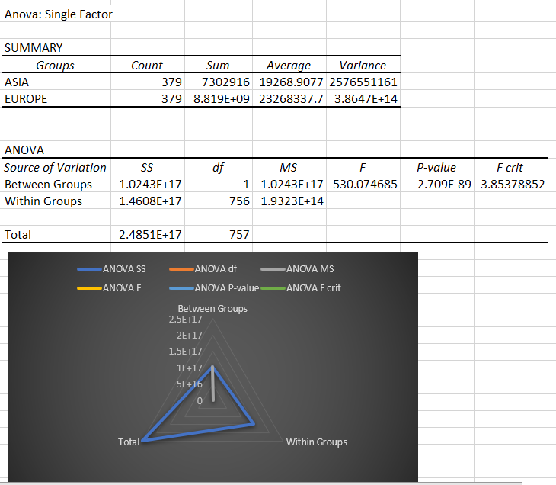

In the context of this ANOVA (Analysis of Variance) test, the hypothesis being examined pertains to whether there is a significant difference in the average values of the variable (possibly related to Youtubers' work) between the two groups (ASIA and EUROPE). Let's break down the hypothesis testing:
- Null Hypothesis (H0):
  - H0​: The mean values of the variable are the same for both ASIA and EUROPE groups.
- Alternative Hypothesis (H1):
  - 1H1​: There is a significant difference in the mean values of the variable between the ASIA and EUROPE groups.
- ANOVA Test:
  - The ANOVA test compares the variance between the groups to the variance within the groups. If the variance between groups is significantly larger than the variance within groups, it suggests that there are significant differences in the mean of the groups.
- Conclusion:
  - Since the p-value (2.70898E-89) is much smaller than the significance level (commonly 0.05), we reject the null hypothesis.
  - The F-ratio is significantly larger than the critical F-value, indicating that the variance between groups is large enough to suggest a significant difference in the means.
2. Overall Interpretation:
- There is strong evidence to suggest that the average values of the variable (possibly related to Youtubers' work) are significantly different between the ASIA and EUROPE groups.
- The ANOVA test provides statistical support for the conclusion that there is variability in the means of the two groups, supporting the rejection of the null hypothesis in favor of the alternative hypothesis.

Research Questions
- Is there a correlation between the number of subscribers and video views for YouTube channels in the "Entertainment" category, and how does this relate to their highest yearly earnings?

- How do Indian YouTube channels in different categories, such as "Comedy," "People & Blogs," and "News & Politics," compare in terms of subscribers, video views, and earnings?

- Are there discernible trends in YouTube channel success based on the continent where the channel is located? Do channels from specific continents tend to attract more subscribers and video views?
Assumptions:
- Sustain data integrity by verifying its accuracy and comprehensiveness.
- The assumption is that higher the subscribers and views for the channels, higher their earnings
- Ensuring that the selected features for prediction are pertinent and do not lead to overfitting of the model.
- The entertainment industry has the highest frequency in the data.
- The Channels registered from India make more uploads compared to the other countries
Conclusion
- The youtubers from developed countries earn more since the content meets the quality which leads to attention to a wide audience. The infrastructural facilities and technology development helps the youtubers make the contents more informative and intuitive.

- The higher the population of the country, the higher the uploads to the channels. Countries like India, US, Australia predominantly uploads contents in YouTube than any other country.

Project Name: YouTube Statistics

Date: 8th October 2023
Task 1: Data Preprocessing and Categorization
Description: In Task 1, I focused on data preprocessing and categorization, aiming to enhance the dataset's structure for further analysis.
Data Source: The dataset was sourced from the Kaggle website.
Tools/Software Used: I utilized Microsoft Excel to perform data preprocessing and categorization.

Steps Taken:
- Opened the dataset in Excel to assess categorical variables.
- Carried out data cleaning, including handling missing values, addressing outliers, and resolving inconsistencies within the columns.
- Executed variable transformations, such as data type conversions, creation of new variables, and recoding existing ones to facilitate categorization.

Challenges/Issues Encountered: Fortunately, no significant challenges or issues were encountered during this initial data exploration.

Date: 13th October 2023
Task 2: Univariate Descriptive Analysis
Description: Task 2 involved conducting univariate descriptive analysis on the quantitative variables. The primary goal was to gain insights into these numerical variables.
Tools/Software Used: For this analysis, I relied on Microsoft Excel.

Steps Taken:
- Initial selection of the quantitative variables to be included in the univariate analysis.
- Computed descriptive statistics, including metrics such as mean, median, mode, variance, standard deviation, range, skewness, and kurtosis for each quantitative variable.
- For categorical variables, generated frequency distribution tables to present the count and proportion of each category, facilitating an examination of category prevalence. Additionally, created histograms for visualization.
- Performed outlier detection through the creation of box charts to identify extreme values or anomalies in the data.
- Summarized key findings from the univariate analysis and documented them in the report.

Challenges/Issues Encountered: No significant challenges or issues were encountered during this initial data exploration.

Date: 23rd October 2023
Task 3: Refining Research Questions
Description: In this task, I refined and updated the research questions to guide the analysis and exploration of the telco company's customer dataset.

Steps Taken:
- Reviewed the dataset's contents, variables, and insights derived from the univariate descriptive analysis.
- Brainstormed potential research questions aligned with the project's objectives and the dataset's variables.
- Evaluated the relevance and feasibility of each research question.
- Refined the research questions to ensure they are clear, specific, and actionable.

This project aims to provide a comprehensive analysis of the YouTube statistics to derive valuable insights and answer pertinent research questions.

Date: 19th November 2023
Tasl 4; Conducting Hypothesis
Description: In this task I performed multiple hypothesis test to check the correlation of different variables when they are compared.

Steps Taken:
  - Conducted ANOVA test, Chi-Square test, Odd Ratio and Relative Risk Ratio & T test.

